Arizona Chapter

May 2023 ‐ pALS Newsletter

Support Groups

Support groups provide opportunities for group members to share their personal experiences and to learn more about living with ALS. They are designed to share information as well as strategies for preserving the independence and quality of life of both people with ALS and their caregivers, and address the social, emotional, and mental challenges of living with this disease. | Central Arizona  Persons with ALS ‐ Tuesday, May 9th from 1‐3 pm  Topic: Respiratory Symptom Management  Held at ALS Association Arizona Chapter office  360 E. Coronado Road, Phoenix, AZ 85004  Caregivers ‐ Tuesday, May 16th from 1‐3 pm  Held at ALS Association Arizona Chapter office  360 E. Coronado Road, Phoenix, AZ 85004  Southern Arizona  Persons with ALS ‐ Monday, May 22nd from 1‐3 pm  Topic: Emergency Preparedness  Held at Our Saviour's Lutheran Church ‐ Activity Building  1200 N Campbell Ave, Tucson, AZ 85719  Caregivers ‐ Wednesday, May 17th, from 1‐3 pm  Held at Our Saviour's Lutheran Church ‐ Activity Building 1200 N Campbell Ave, Tucson, AZ 85719

Support groups are in‐person, hybrid or virtual as noted. Please join the group that works for you!  If you are unsure which group is best for you, please call the  office at 602‐297‐3800 for assistance. | Northern Arizona  Persons with ALS ‐ Monday, May 22nd from 1‐3 pm  Held at Starting Point Church‐ lounge area  3106 Gateway Boulevard, Prescott, AZ 86303  Hybrid/Virtual  Caregivers ‐ Tuesday, May 16th from 1‐3 pm  Phoenix pALS ‐ Tuesday, May 9th from 1‐3 pm  Tucson pALS ‐ Monday, May 22nd from 1‐3 pm  Page 2: Survivors ‐ Wednesday, May 17th from 5:30‐ 7:30pm  Join virtual meetings from your computer, tablet, or smartphone.  https://global.gotomeeting.com/join/951959885  You can also dial in using your phone.  United States: +1 (408) 650‐3123 Access Code: 951‐959‐885
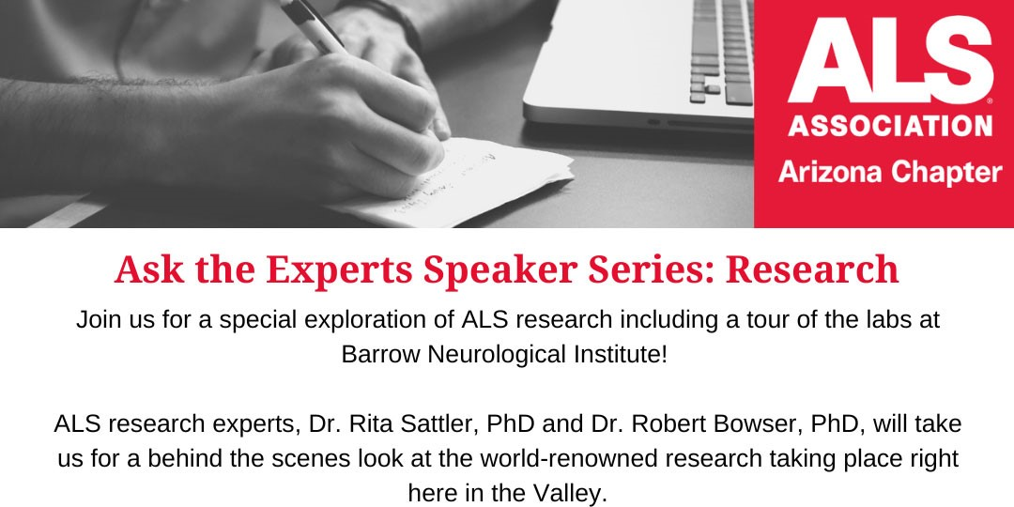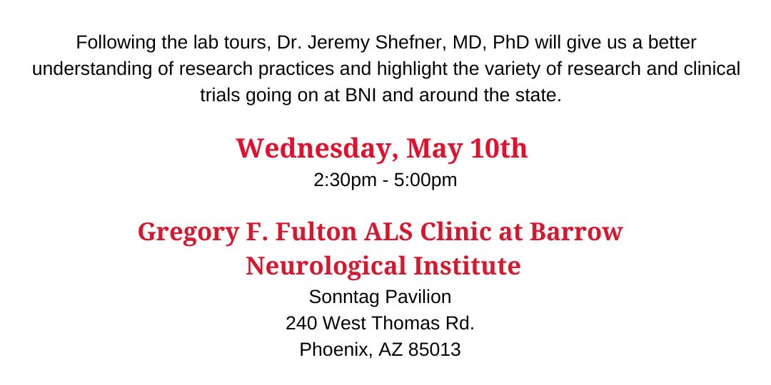
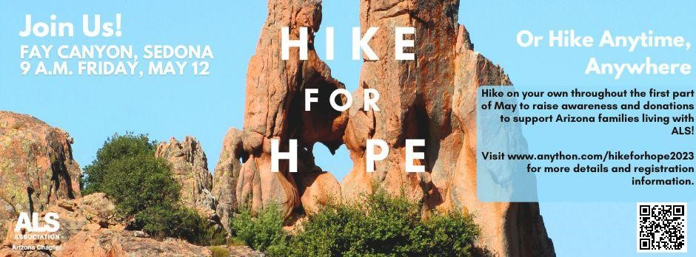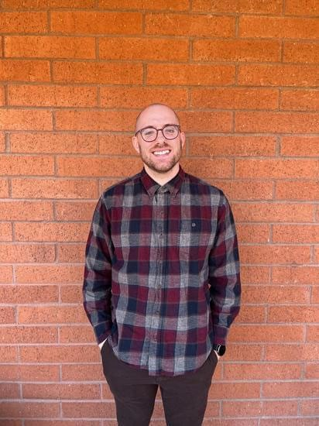

We're

kicking

off

ALS

Awareness

Month

with

our

third

annual

Hike

for

Hope!

Register Here

Welcome

our

new

Care

Services

Coordinator,

David!

Hi,

my

name

is

David

Doty.

I

am

from

a

tiny

town

in

the

middle

of

Nevada

called

Sandy

Valley.

I

am

a

recent

Social

Work

graduate

and

live

in

Phoenix

with

my

wife

and

our

dog.

I

am

very

excited

to

be

here

and

to

be

part

of

the

ALS

Association

Arizona

Chapter!

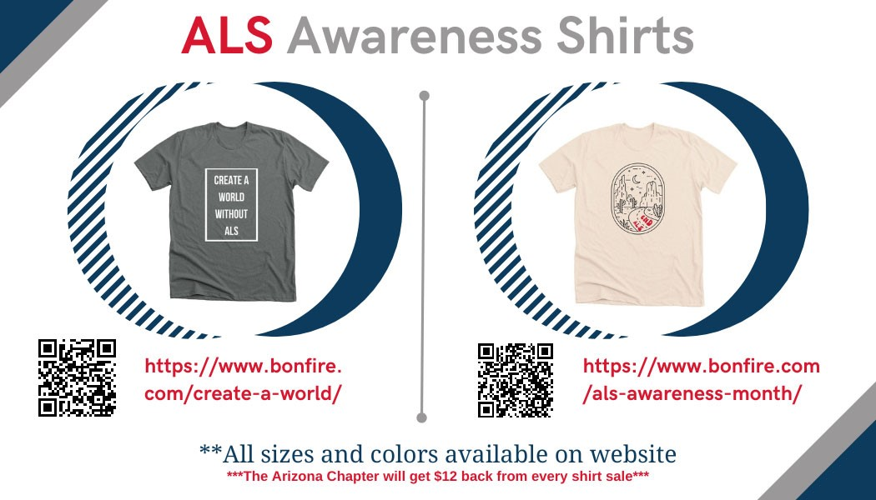
May

is

ALS

Awareness

Month

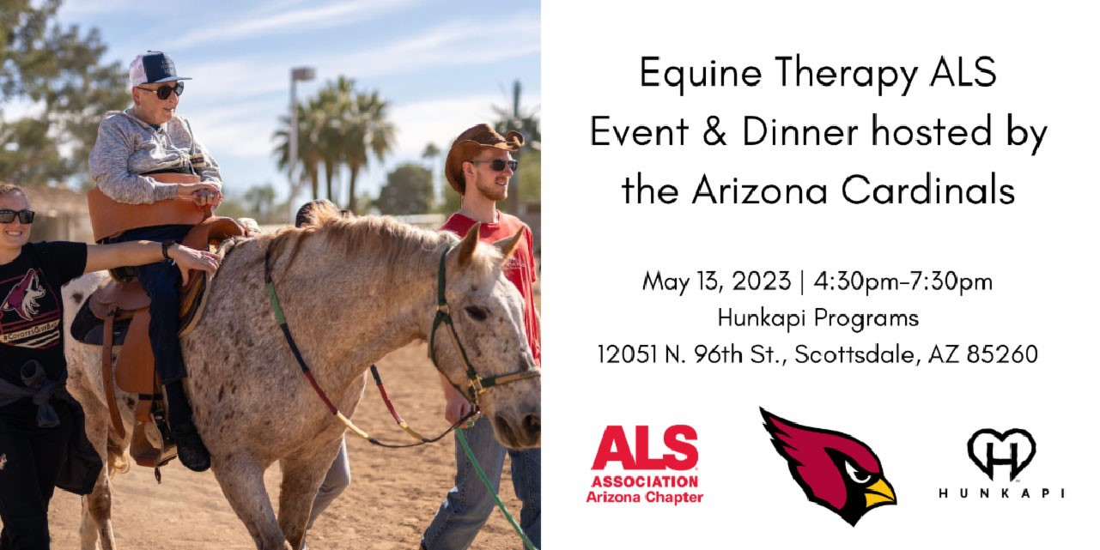
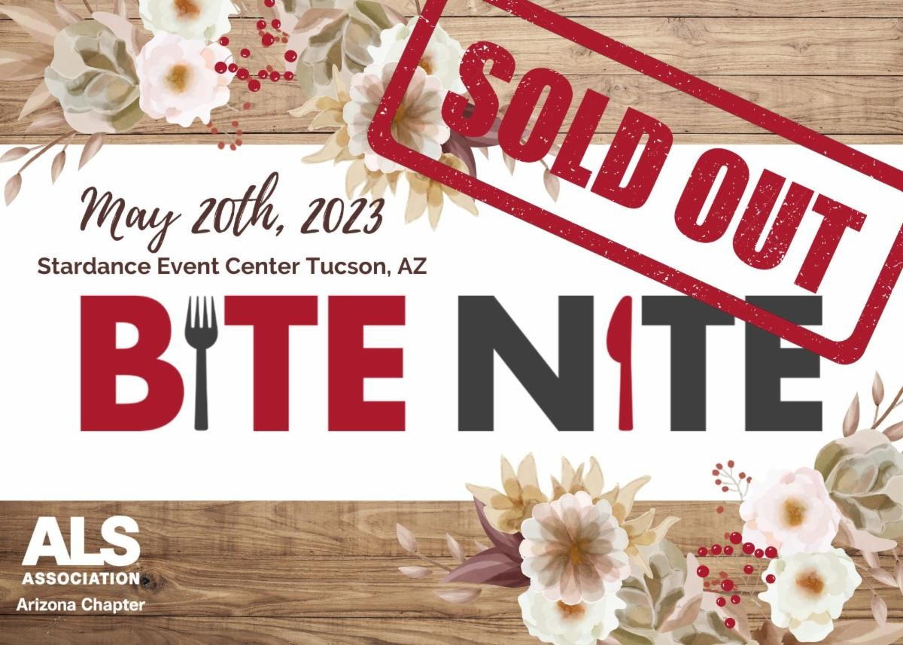
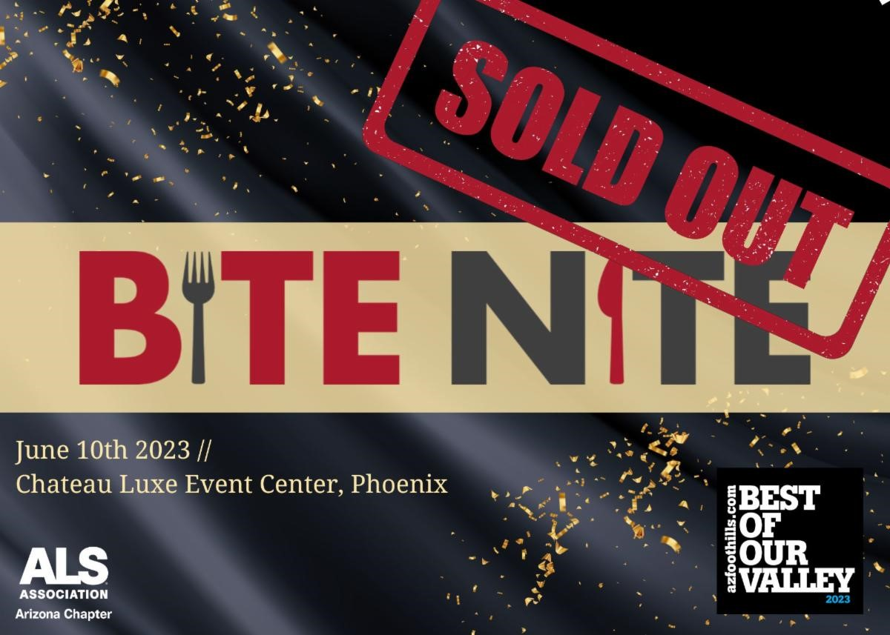
Volunteers Needed

V
olunteers Needed For a S
p
ecial Event at Hunka
p
i Farms

The afternoon will begin in the arena with equine therapy and conclude with a beautiful
dinner provided by the Arizona Cardinals. Arizona Cardinals football players,
cheerleaders, and Big Red will join pALS for the dinner festivities! We are looking for
volunteers to assist with this beautiful event!

Schedule of Events:

· Equine Therapy - 4:30pm-6:30pm

· Dinner on the Manna Lawn - 6:30pm-7:30pm

Volunteer
VoulVoulsdjjoienklf

Bite

Nite

Phoenix

and

Bite

Nite

Tucson

are

officially

SOLD

OUT!

Thank

you

SO

much

to

all

of

our

supporters,

sponsors,

and

restaurants

for

helping

us

reach

this

milestone.

We

can't

wait

to

celebrate

with

you

in

May

and

June!!

Education Corner

There are always chances to learn more about advances in ALS research, ways to increase the quality of life, and to hear from experts in the field! Below are some opportunities for you to explore:
- Tofersen Approved for SOD1‐ALS
- On April 25, 2023, the FDA announced it had granted accelerated approval to Tofersen, a treatment for people living with ALS tied to mutations of the SOD1 gene. This is a significant victory for the ALS community and our efforts to make ALS liveable until we can find a cure. Read More Here

- Thank You for Advocating for ALS Research Funding
- Thank you for helping secure 80 representatives on the House Dear Colleague Letter and 32 senators on the Senate Dear Colleague Letter. This letter includes our requests for increased funding for ALS research
critical to developing new treatments and cures. You can review our
funding requests and the list of signers here.

In Remembrance
We extend our deepest sympathy and continued support to the families and friends of:
Joseph Delvecchio, Todd Fitzgerald, Ruth Heatherly, Judith Johnson,
Linda Lennon, Mary "Diane" McDermott, Connie Melton, Lynn Reiter,
Mickey Tryon

The ALS Association Arizona Chapter
360 E. Coronado Road, Suite 140 Phoenix, AZ 85004

Try email marketing for free today!

602‐297‐3800 www.alsaz.org

