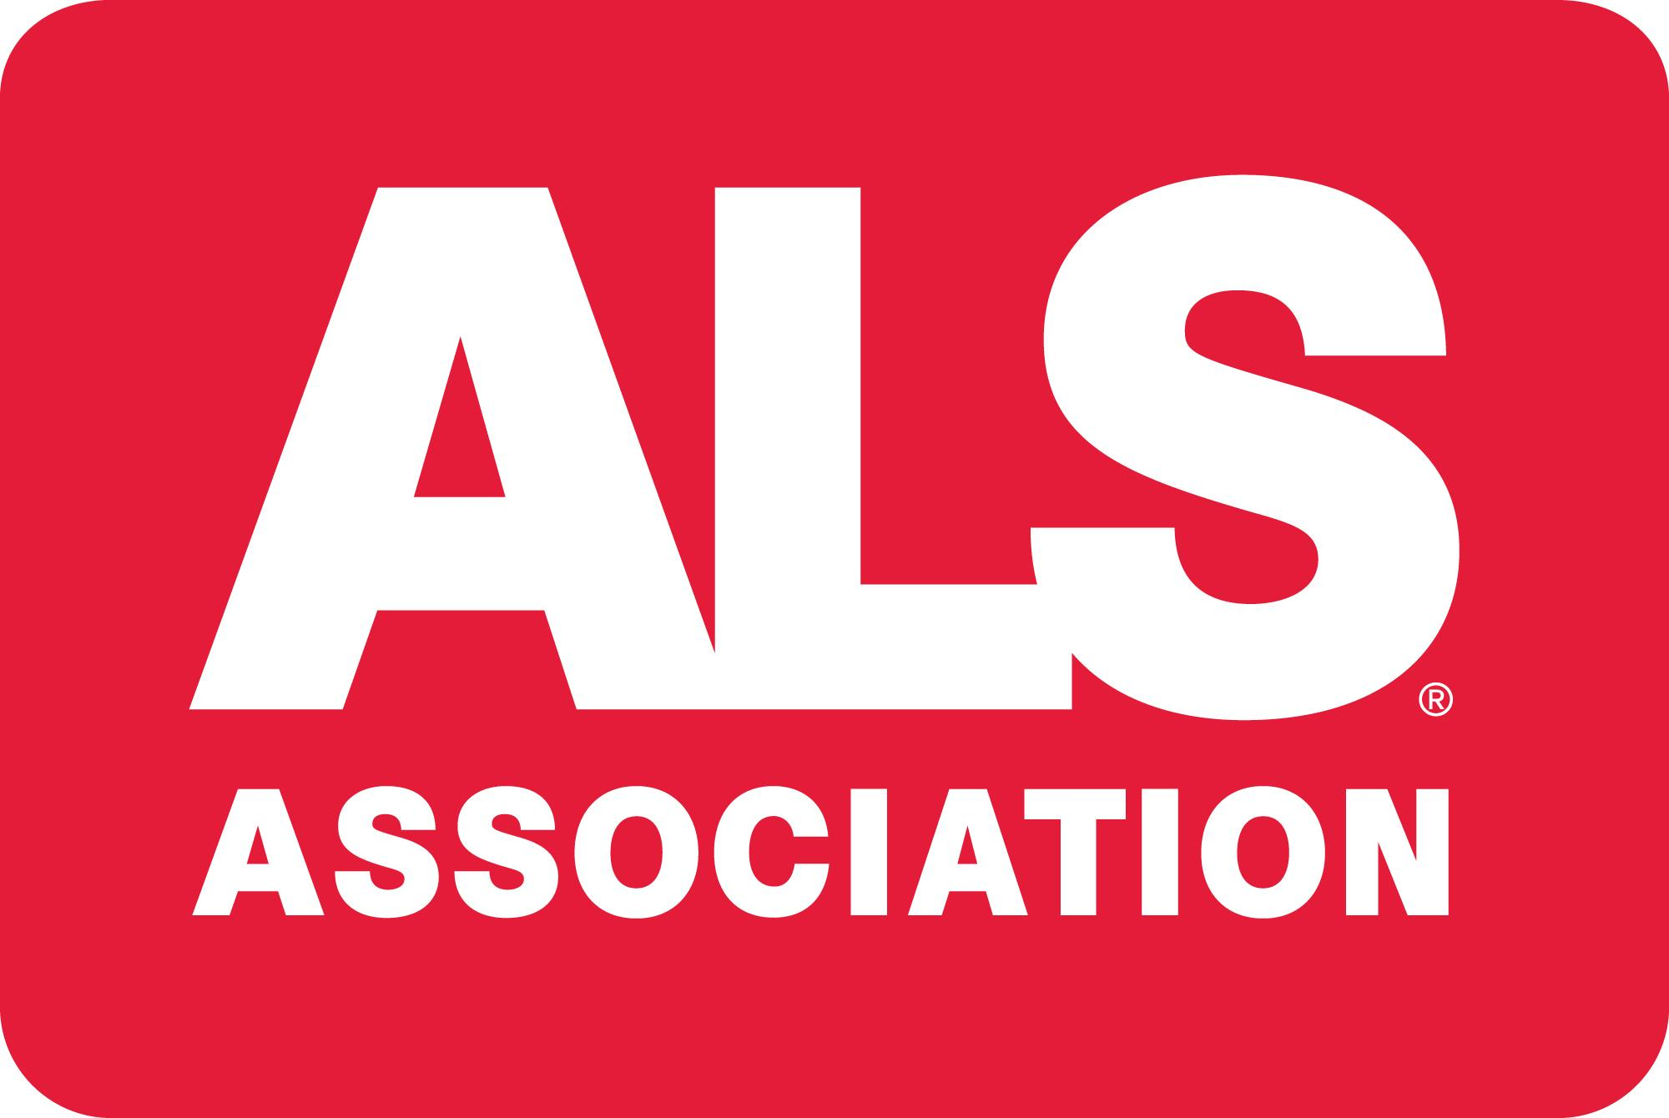

Voice Preservation
What is it?
As ALS progresses it may become more difficult to speak clearly. If needed you can use an electronic device (smartphone, iPad/tablet, or a dedicated Speech Generating Device) that can speak a typed or selected message to support your communication.

Voice Preservation is the process of recording your voice so that the voice that comes out of a speech device mimics your own voice.

Voice Preservation includes two parts;
- Voice Banking - This is the process of creating a synthetic/computerized voice that sounds like you so that anything you type can be spoken in your computerized voice.
- Message Banking - This is the process of recording you saying an entire message so that the inflection and personality are heard, instead of being the computerized version of your voice you get with voice banking.

Who is a good candidate?
Voice Preservation is recommended for anyone living with ALS who is able to clearly speak a full sentence. If your speech is mildly or even moderately impaired you may still be able to complete the process. If your speech is severely impaired you can have a family member or friend complete the process for you (then their voice would be heard through the speech device). It is highly recommended that voice preservation be completed as soon as possible before any significant decline in speech clarity.

Reasons to do it
- It doesn’t take long: the Voice Banking process can be completed in 20-30 minutes. This can be done all at once or in multiple sittings if needed. Message Banking can be ongoing and completed at your own pace.
- It’s yours to keep: Recordings can be kept by family members, allowing them to hear your voice for years to come
- It’s “More you than Siri”: Even if you have noticed changes in your speech this will sound more like you than the generic computerized voice
- You don’t have to use it: If you complete the process and don’t like the outcome you don’t have to use it
- It’s free: Funding is provided by Team Gleason, equipment provided by ALS Association

How to get started
- Contact Kate at the ALS Association; 651-455-6687 or kate@alsmn.org

